**Australian Islamic College 2018**

**ATAR Chemistry Units 3 and 4**

**Task 5 (Weighting: 3%)**

**Volumetric Analysis Test**

Test Time: 30 minutes

Please do not turn this page until instructed to do so.

|  |  |
| --- | --- |
| **First Name** | **Surname** |
|  |  |

|  |
| --- |
| **Teacher** |
|  |

|  |  |
| --- | --- |
| **Mark / 21** | **Percentage** |
|  |  |

Equipment allowed: Pens, pencils, erasers, whiteout, rulers and non-programmable calculators permitted by the Schools Curriculum and Standards Authority.

**Special condition**: 2 marks will be deducted for failing to write your full name on this test paper.

Teacher help: Your teacher can only help you during your test in one situation.

If you believe there is a mistake in a question show your teacher and your teacher will tell you whether or not there is a mistake in the question and if appropriate, how to fix that mistake.

Questions must be answered in this booklet, in the spaces provided.

Total marks: 21

1. In a titration to determine the concentration of a hydrochloric acid solution using a sodium hydroxide standard solution the following results were collected.

|  |  |  |  |  |  |
| --- | --- | --- | --- | --- | --- |
|  | Trial 1 | Trial 2 | Trial 3 | Trial 4 | Trial 5 |
| Initial burette reading (mL) | 0.0 | 3.6 | 10.2 | 5.5 | 4.4 |
| Final burette reading (mL) | 25.3 | 27.6 | 34.3 | 31.6 | 28.6 |
| Titre (mL) |  |  |  |  |  |

What average value for the titre should be used for the calculations of the hydrochloric acid concentration? [1 mark]

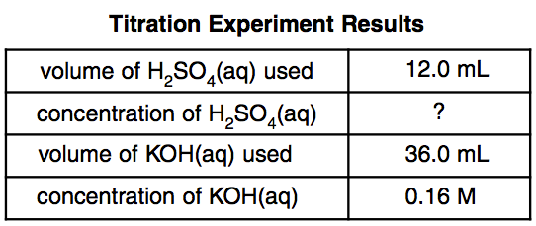

1. The table above summarises the results of a titration.
   1. Name the analyte. [1 mark]

* 1. Name the standard solution. [1 mark]

* 1. State one reason why the substance you named in part (b) is unlikely to have been the primary standard solution. [1 mark]

* 1. Determine the concentration of the analyte. Express your answer to the appropriate number of significant figures. [1 mark]

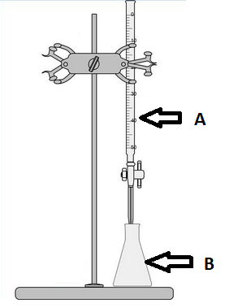

1. All of Question 3 refers to the diagram above.
   1. What is the name of the piece of equipment labelled ‘A’?

[1 mark]

* 1. With what should the final rinse of the piece of equipment labelled ‘B’ be performed? [1 mark]

* 1. What word describes the measured volume of liquid dispensed from ‘A’ to reach the endpoint? [1 mark]

* 1. How is the endpoint typically recognised during an acid-base titration such as the ones performed in our classroom? [1 mark]

* 1. How will the final calculation of analyte concentration be affected if, every time a titration is performed, the volumes in equipment ‘A’ are measured from the top of the meniscus instead of the bottom of the meniscus? Justify your answer. [2 marks]

* 1. When preparing for a titration using the equipment above 1.54 g of primary standard was dissolved in 250 mL of distilled water instead of 1.45 g, as intended.
     1. What type of error will this cause? Circle the correct answer from the three choices below. [1 mark]

Systematic / Random / No error

* + 1. How will the final calculation of analyte concentration differ from the true value? Circle the correct answer from the three choices below. [1 mark]

Too high / Too low / No change

* 1. The equipment shown in the diagram at the start of this question was used to perform a titration. Hydrochloric acid was placed in the burette and a solution of sodium hydrogen carbonate was placed in the conical flask.

Sketch the titration curve on the grid below, label the vertical axis (Y-axis) appropriately and label the equivalence point.

[4 marks]

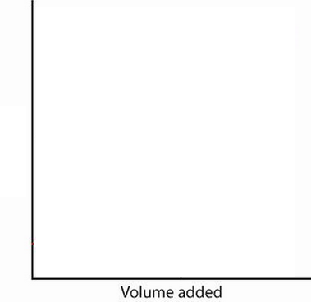

1. To determine the purity of a sample of copper(II) oxide, a 20.56 g sample of the impure substance was reacted with 500.0 mL of 1.10 mol L-1 hydrochloric acid, an excess. After this reaction was complete a 25 mL aliquot of the acid was titrated against a standard solution of 0.100 mol L-1 NaOH. An average titre of 25.4 mL was required to reach the endpoint.

Determine the percentage purity of the copper(II) oxide and express your answer to the appropriate number of significant figures. [4 marks]

**END OF TEST**